Fratellanza Women’s Social Club
72nd Anniversary Dinner
Saturday, March 25, 2017
No Host Cocktails from6:00pm with Dinner at 7:00pm
Menu:
Caesar Salad
Tortellini
Steak w Baked Potato and Fresh Asparagus
Tiramisu w Coffee
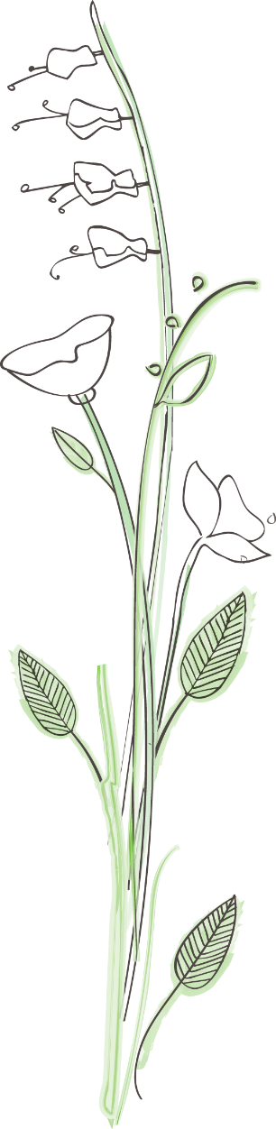
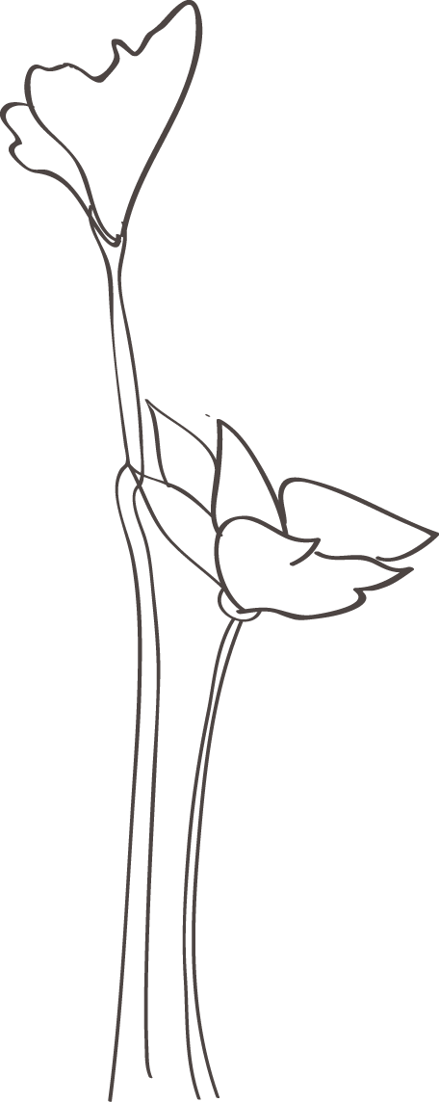
Following Dinner, Dancing to: Albert Garcia and his Band
$25 Per Person
RSVP by March 17, 2017 to:
Loretta Iacobitti, Tel: 510 524-6903
Location: Fratellanza Club
1140 66th St. Oakland, CA, 94608

.

